# Document Information

|  |  |
| --- | --- |
| **Project name:** | Show of Hands |
| **Date:** | 7/2/2021 |
| **Author:** | Diarmuid McKenna |
| **Owner** | Jason Quinlan |
| **Document code:** |  |
| **Version:** | 0.2 |
| Approval |  |
| **Date** | **Name and Signature** |

# Definition

|  |  |
| --- | --- |
| **Background:** | With COVID-19 still an issue in much of the world, in-person voting systems will experience lower levels of voter participation due to health concerns. With this in mind, we thought that a web-based election system would allow a user (from individuals to corporations) to hold an online election in order to maximize remote voter participation. |
| **Main Goal:** | A web-based election system offering high usability and customizability to election organizers, candidates and voters. |
| **Desired Outcomes:** | As none of us have extensive experience in creating software as a team, we hope to improve our ability to work efficiently in a team. This includes our ability to communicate effectively and to organize ourselves in a way that allows us to complete tasks to a high standard and in line with the deadlines set by the Product Owner.  Furthermore, we plan to use new frameworks to develop many aspects of the products. We hope to gain knowledge and experience in these frameworks that we can carry forward into our placements. |

**Constraints and Assumptions:** This project has no flexibility in terms of time or team members, as number of team members and deadlines are fixed. Due to the current state of affairs, we will not have the opportunity to meet in person to work on the project. Therefore, all our communication is restricted to online calls or messages.

As of now we don’t plan on restricting our compatibility to one specific browser although this may be subject to change.

work with all of the frameworks , the use of firebase has some constraints.

|  |  |
| --- | --- |
| **Framework** | react for front end and UI , firebox for security and backend |
| **Project Approach:** | We don’t plan to use or build upon an existing project so our software will be developed in-house. We plan to use the Scrum framework to develop the product and conduct a daily stand up so that we are all on the same page and can ensure we’re on track to meet deadlines and goals. |
| **Project Product Description:** | A web application that serves as a platform for election organizers to hold an election. We will offer organizers a high level of customization in terms of type of voting system (ranked choice or popular vote mechanism) as well as the decision whether to have anonymous voting or not. |

We will allow candidates in an election to have a profile where they can include a manifesto or credentials which would allow voters to make a more informed decision on what candidate to vote for.

We also want to offer election organizers the opportunity to choose who participates in their election, from an open or public election to an election where only a defined group of users can vote in.

# Outline Business Case

A web-based election system would automate an election system which is desirable for organizations as they can cut costs whilst also holding an election where the only barrier to vote will be an internet connection, resulting in higher voter participation. We are differentiating from competitors by having high levels of customization within the voting system and eligibility of voters and allowing candidates in an election to create a profile where they can include a manifesto.

specific with competition and features they lack and how we achieve them . Address how we do it differently other competitors.

More of a public market , easier to use , although will be less extensive

# Key Stakeholders

|  |  |  |
| --- | --- | --- |
| **Major Stakeholder** | **Notes** | |
| **Jason** | Product owner | |
| **Diarmuid, Finbarr, Con, Jack, Luke** | Software Development team member | |
| Project Objectives |  |  |
|  | **Target** | **Tolerance** |
| **Scope** | Fully flexible voting systems that organizers can choose from    Web Application (UI)  Profile Database  Moscow | Just one voting system, popular vote  left to right in Moscow implement them one by one. |

|  |  |  |  |
| --- | --- | --- | --- |
|  | | Authentication System |  |
| **Time** | | 7 weeks | No flexibility, we must use the full 7 weeks and no more. |
| **Cost** | | N/A | N/A |
| **Quality** | | Add features specific to the app , candidate profiles , invite links etc..  security from firebase (no control over that) , we intend to have robust system , user authentication to ensure security , only debug once . |  |
| **Risks** | | Using new frameworks or languages forces us to include learning time into our schedule which will hinder the quality of the project.  Scheduling is strict and if a team member cannot complete their assigned duties, the project will suffer. | Factoring in time to learn new skills allows us to be realistic in our vision of the result. We can also develop features in order of priority so that  important features can be implemented and functional, increasing the flexibility of the schedule.  The members of the team are flexible and can adapt to new workloads along the way allowing development to continue in the event of an absent team member. |
| **Benefits** | | Learning new skills will benefit each member of the team.  The user can use the platform to reduce the workload involved in organizing or participating in remote elections and votes. |  |
| Project Management Team | | |  |
| **Role** | **Reports to Appointee** | | |
| **Team Lead**  Motivating and inspiring team members.  Organizing the groups Daily Scrum meetings.  Directing team members being sensitive to the teams needs. | **Luke** | | |
| **Front end**  Implementing the front end design in React | **Luke** | | |

**Front end Jack**

Visual/Functional design of

main UI elements and views.

|  |
| --- |
| **Front End Finbarr**  Add CSS to the React to conform  with Jack’s design. |

**Back End Diarmuid , Con**

Implemented the beginning of the

profile system and have investigated the

functions and complexities of Firebase

(the platform we decided on using to help create our

Web App)

Progress Made Week 2 :

* We pushed our first basic structure of the initial layout as well as working on the CSS for it.
* We have designed the pages we have decided on, for of our web app, and have started to implement the design in react with the appropriate CSS.
* Progress has been made with the interaction between the web app and the Firebase storage. We can now create collections of each type of user using our Web app.
* We decided on the majority of the Views, to which the Project will incorporate. Of course more can be added or removed if need be .
* Finalized the Scrum Rota for the coming weeks.
* Created a Use Case Diagram to help us picture the overall functioning of the App.

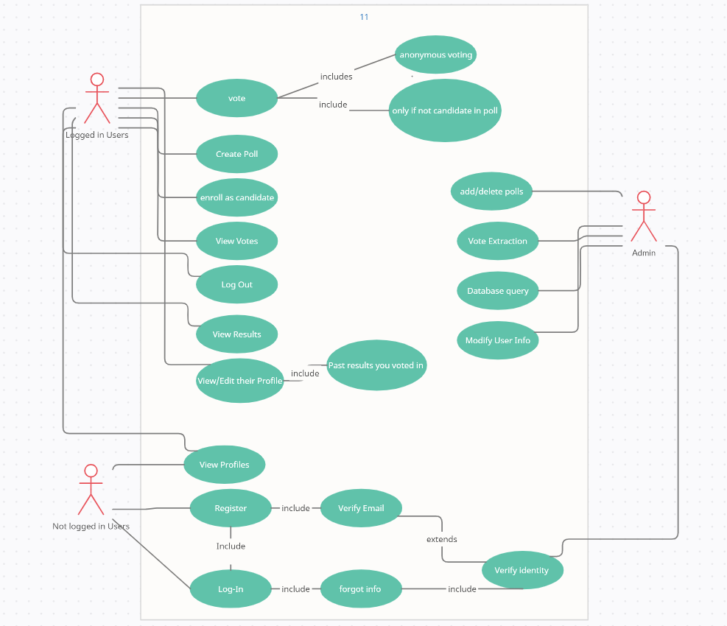

**- - - - PRINCE2**® **Templates - - - -**

A guide for this template, it’s latest version, and all other templates are available at [mplaza.pm/templates](https://mplaza.pm/templates)

Also, you may be interested in using our PRINCE2 eLearning Courses available at [mplaza.pm](https://mplaza.pm/)

Copyright 2018, Management Plaza

You can use this document for free in your projects and for your personal purposes. Redistributing this document or using it for training requires permission from Management Plaza.

This document is based on AXELOS PRINCE2® material. Reproduced under licence from AXELOS. All rights reserved.